**Electronics II Lab Couse Project**

**Keegan** **Smith**

**Electronics** 2 Lab

**EECE.3120 803**

**Date submitte**d 12/07/2022

**Due date** 012/07/2022

**Summary/Abstract**

The objective of this circuit is to be a hardware implementation of an automatic watering system using a moisture sensor, op-amp, MOSFETs, water pump, and a normally-closed solenoid as a value. The heart of this circuit is the op-amp in the comparator configuration because the reference voltage is the “target moisture level” and whenever the voltage from the moisture sensor is lower than the target voltage, the comparator will produce a high, 3.5-volt output, see table 1. This is then fed into a voltage divider bringing down the voltage to around 2.33v for the MOSFET switches, thus controlling the solenoid and the water pump. The target voltage of 2.28v is created with another voltage divider off of the 5v rail.

**Components**

|  |  |  |
| --- | --- | --- |
| **Component Type** | **Quantity** | **Details** |
| Motor | 1 | Mini Water Pump DC 3V-5V Micro Submersible Motor Pump |
| Solenoid | 1 | DIGITEN DC 12V 1/4" Inlet Feed Water Solenoid Valve Quick Connect N/C |
| Moisture Sensor | 1 | SparkFun (PID SEN-13637) |
| Operational Amplifier Comparator | 1 | LM358 |
| Switch | 1 | 5V Switch |
| MOSFET | 2 | 2N7000 |
| Resistor | 1 | 10 Ω |
| Resistor | 1 | 1k Ω |
| Resistor | 1 | 2k Ω |
| Resistor | 1 | 1.1k Ω |
| Voltage Regulator | 1 | AMS1117 5.0 |
| Voltage Regulator | 1 | AMS1117 3.3 |

**Schematic**

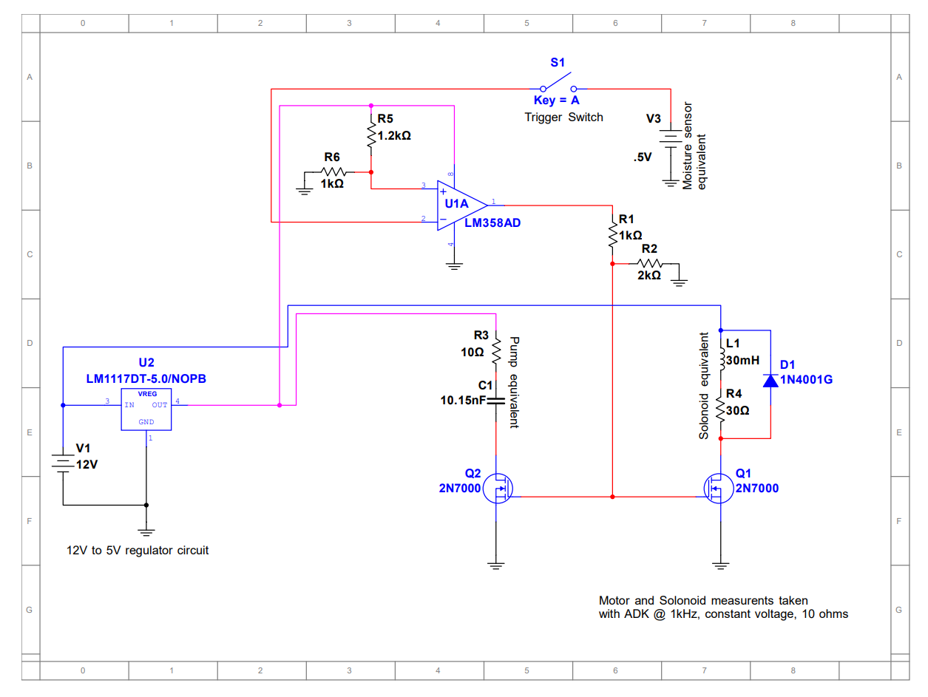**Figure 1.** Current system configuration with 5v pump and 12v solenoid (3.3v moisture sensor)

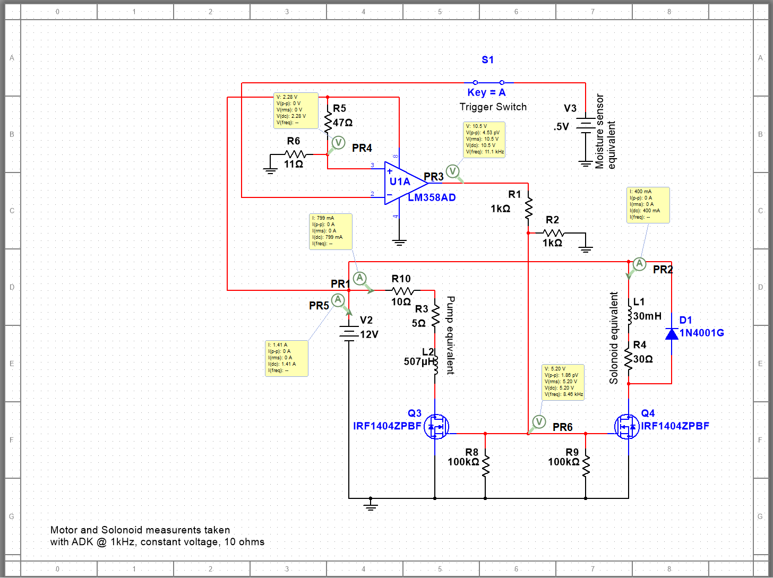**Figure 2.** Ideal 12v system with high current FETs, 12V pump and solenoid (3.3v moisture sensor)

**Circuit Description**

**Table 1.** Comparator Table U1 (VS+ = 5v, VS- = 0)

|  |  |  |  |
| --- | --- | --- | --- |
| Vin- | | Vin+ | Vout |
| Vin- | > | 2.28 | 0 |
| Vin- | < | 2.28 | 3.7v** |
| Vin- | = | 2.28 | 0*** |

**3.7v due to the voltage drop across the operational amplifier

*** Not actually possible because the voltages are never equal in a practical application

**Analysis/ Equations**

Voltage divider equation: $V_{n}= V_{s}\frac{R_{2}}{R_{1}+R_{2}}$

In the voltage divider equation, Vn is the nodal voltage. In the case for the “target” voltage, R2 and R1 are respectively equal to R6(1kΩ) and R5(1.2kΩ) from the schematic. For the FET input voltage divider, the nomenclature in the formula may be used.

**Results/Conclusions**

The results from the circuit simulation looked solid enough in theory to construct the circuit. However, after doing so, I found the circuit to not work quite well. The comparator circuit and the moisture sensor work exactly as expected, but the FETs and voltage regulators did not. After some testing I noticed something I did not look for in the simulations because I could not include the actual pump and solenoid. What I found was that the FETs would not allow enough current through, and the voltage regulators would drop voltage very quickly. According to the data sheet for the regulators (they have the same data sheet), the max current draw is around 1.5A, which would work just fine for the circuit, but I suspect they may have been damaged from previous testing. The last issue is my choice of FETs was wrong. The 2N7000 MOSFETs are enchantment type FETs, meaning more gate voltage, more current is allowed to go through and the max, continuous current draw is 350mA. What the circuit needs are logic level, high current, switching MOSFETs such as the IRFP1405PbF from International Rectifier. These would allow the pump and solenoid to continuously draw as much current as they want, while being controlled by a 2.0-4.0V voltage source, such as the comparator.

An upgrade I would like to make to the circuit is using a 5v solenoid instead of the current 12v. This would allow the removal of the 5-volt voltage regulator as well as allow for a decrease in battery voltage, allowing for a 5-volt battery, or a 9-volt battery with a 5v regulator for the ease of user experience changing or charging batteries.

**References/Datasheets**

1. *2N7000/2N7002 Datasheet - STMicroelectronics*. https://media.digikey.com/pdf/Data%20Sheets/ST%20Microelectronics%20PDFS/2N7000,%202N7002.pdf.
2. *Advanced Monolithic Systems*. http://www.advanced-monolithic.com/pdf/ds1117.pdf.
3. *Industry-Standard Dual Operational Amplifiers Well as Industry Standard ...* <https://www.ti.com/lit/ds/symlink/lm358.pdf?HQS=dis-dk-null-digikeymode-dsf-pf-null-wwe&ts=1640013363982&ref_url=https%253A%252F%252Fwww.ti.com%252Fgeneral%252Fdocs%252Fsuppproductinfo.tsp%253FdistId%253D10%2526gotoUrl%253Dhttps%253A%252F%252Fwww.ti.com%252Flit%252Fgpn%252Flm358>.
4. *IRFP1405PBF Product Data Sheet - Mouser Electronics*. https://www.mouser.com/datasheet/2/196/Infineon_IRFP1405_DataSheet_v01_01_EN-1732737.pdf.